**Test and Evaluation**

1. (i) I have approximately 240 lines of my own CSS

(ii) and approximately 40 lines of adjusted CSS code

(iii) I didn’t use a CSS framework and just did separate CSS files for each page using the main HTML template of image, navigation and footer with different CSS in the body of each page.

1. Speed

(i)

(ii)

(iii)

1. Responsive
2. & (e)

**Expert Review Feedback**

I gave my website, which wasn’t fully completed (but 90% completed) to somebody I know who works as a Web Developer. She currently works in America but has a few years experience in Europe also. I thought this would be good as website design can differ from place to place and it could give me an insight into things I may have overlooked while designing *this* site. However, it could be argued that due to this website being useful to only people in the Dublin area it doesn’t need to be reviewed by people who wouldn’t be using it. I decided to do it anyway from a design point of view rather than a practical one.

The four main areas my “survey” covered were:

* Design – how it looks? Is the colour scheme appealing? Do you like the layout? Is it modern? Would you change anything?
* Usability – Speed? Do all the pages/links/text fields work?
* Navigation – Is it easy to navigate? Do you know where to go before you click on a link or tab or where you will be brought to after you click?
* Content – Is the content relevant? Is there too much/not enough? Do you understand what the website would be used for?

I sent these as open ended questions, as an email and not in any particular format. They were intended to be used as things to think about during and after looking at my site and commented on. The following is the feedback I received….

**Design**

The layout was nice and clean and simple with clearly marked navigation due to the colour scheme but the colour scheme itself was hard to read with the orange over grey. However this was not an issue on the home page as the white background of the content made it very clear. I was also advised to move my “Sign In” tab to the top right of the page as it is where most people would expect it to be, as with majority of other sites.

**Usability**

In my nav bar I was using words like “Login” and “Registration Form”. I was advised to use verbs like “Sign In” and “Register” as they invite the user to interact.

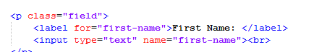

Originally I had my label tags below my input tags but was advised to move them above as it makes it more usable to the user as it is what they expect when filling out fields in a form.

**Navigation**

As part of the navigation section I just gave the survey taker a task to complete. From the moment the home page is opened I asked her to: Find upcoming events, choose a route and send me a message to confirm that she would be attending that event. She said that this wasn’t too difficult but it was due to how little content I had on the page so it was easy to find. Maybe *“YOU”* could try the same task now??!

**Content**

The content was pretty minimal but I think it’s sufficient for what the website is intended to do. So I was just advised again about how things where worded. For example, originally I had “Events Coming Soon” but changed it to “Events” and had “click below for upcoming cycles in Dublin” but changed it to “Upcoming Dublin Cycles” and made that the actual link instead of putting the link below.

**Implementation**

**Use Of CSS3**

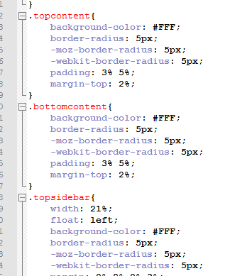

Use of *border-radius* which adds rounded borders to my content on home page. By applying only one value to this, it automatically assigns it to all other corners.

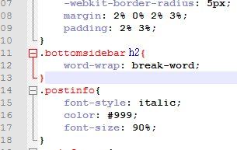

Use of *word-wrap* allows long words to be broken up and wrap into next line. I used this on my bottomsidebar class so when the page was minimized the heading would not break out of the white content background.

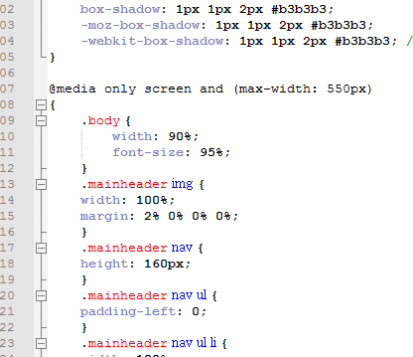

Use of *@media* which allows responsiveness to the page when viewed on another device, or manually minimized on a desktop page. Here it states that when the max-width goes below 550px(which is a standard tablet size) then the width goes to 90% from its original 75% as I didn’t need any space at sides of screen as screen is smaller.

**Use Of HTML5**

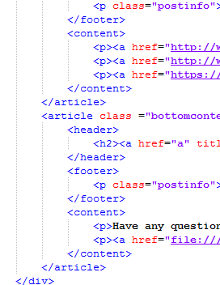

Here you see the use of HTML5 using the *footer*, *content*, *article* and *header* tags.

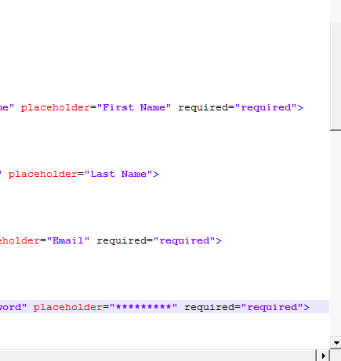

Use of the required attribute. This is a Boolean attribute which informs user that a fied they did not fill out needs to be filled out to be completed.

**Responsiveness**

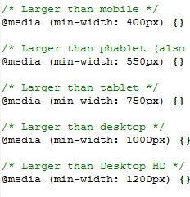

I dealt with my responsiveness by assigning a @media which queries the size the of the screen and allows the user through CSS to assign different values to exsiting CSS to make them act differently under smaller screen size diffrences.

**JavaScript**

**Forms and Iframes**